***PROJECT SCOPE***

**Project scope is vital for successful project execution and involves understanding all of a project’s key elements. Here’s what you need to know to achieve your project goals.**

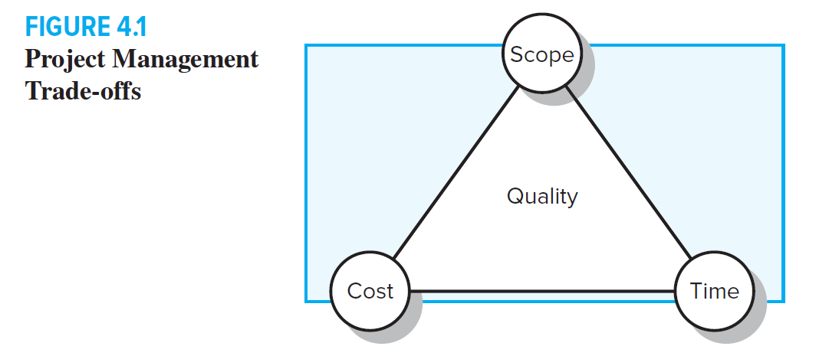

***Clearly defining your project’s scope helps to effectively manage stakeholder expectations and ensures that all of the project’s elements are aligned with the objectives — increasing the chances of success. Here’s what you need to know about defining project scope.***

## *THE definition OF PROJECTSCOPE ::*

***Project scope is a detailed outline of all aspects of a project, including all related activities, resources, timelines, and deliverables, as well as the project’s boundaries. A project scope also outlines key stakeholders, processes, assumptions, and constraints, as well as what the project is about, what is included, and what isn’t. All of this essential information is documented in a scope statement.***

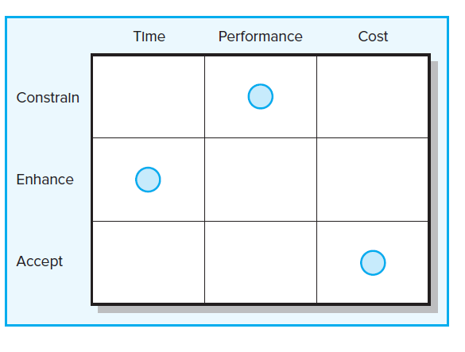

## The project scope statement

***The project scope statement is a key document that provides all stakeholders with a clear understanding of why the project was initiated and defines its key goals. Most project scope statements will include these elements.***

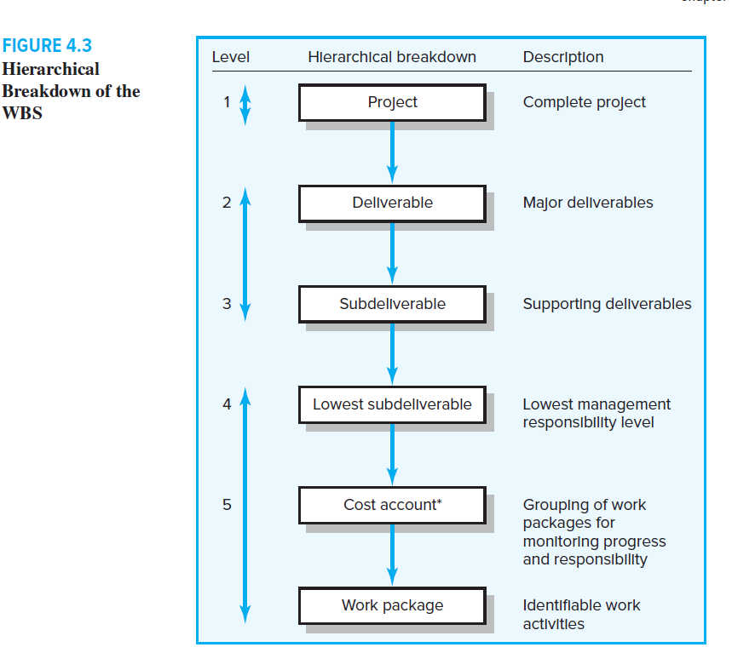

* ***A project statement of work (SoW), which is a detailed breakdown of all work to be performed by a project team and any important elements that may impact the outcome***
* ***Constraints that might limit or negatively impact the outcome of the project, including resources, procurement issues, timing, or lack of information***
* ***Scope exclusions, which can be anything that will not be part of the project or its deliverables***
* ***Milestones that provide the exact date that something will be delivered or completed***
* ***The final deliverables that will be provided to the customer at the end of the project — for example, a report, a software feature, any process insights or analysis, or any product or service that a customer needs***
* ***Acceptance criteria that spell out exactly how success will be measured***
* ***Final approval whereby the customer will sign-off on the scope statement confirming that all parameters have been included and the document is complete and accurate***

## Key steps for defining your project scope

***Properly defining the scope of a project is the key to successfully managing your project. Here are the steps you can follow to define your project scope.***

## *Project scope example*

**Let’s say you are a project manager defining the scope for a content marketing project. A very simple project scope statement might include the following.**

### *Project Scope*

***This project will include research, content strategy, writing the article, and publishing it on XYZ’s website under the XYZ blog. It will also include sharing the article on social media for the month of April 2020. All activities will be conducted by Joe Smith of ABC company.***

### *Project Deliverables*

***Project deliverables will include one well-researched written article of up to 1,000 words to be delivered by email to Jane@XYZ.com no later than ___ date.***

### *Project Acceptance Criteria*

***Jane at XYZ company will review and approve the final article version before publishing.***

### *Project Exclusions*

***This project will not include payment to external vendors for research or outsourced services.***

### *Project Constraints*

***Constraints may include communication delays, changes in scope, or technical difficulties.***

## *Project scope management*

**In addition to the ongoing review and monitoring of project activities, there are steps that should be undertaken to manage the scope of the project to avoid scope creep.**

1. **Identify whether there are any changes to the requirements for your project. This is a vital step since these changes directly affect the project goals and all related activities.**
2. **Identify how the changes will impact the project. Before you can make adjustments to the scope of the project, you need to understand where and how changes impact the outcome.**
3. **Gain approval for changes before proceeding with a change in activities or direction.**
4. **Implement the approved changes in a timely manner to reduce delays and risks.**

## Project scope template

#### Introduction

The Introduction provides a high-level overview of the project.

#### Project Scope

State the scope of the project. This should include what the project does and does not include. This will help to clarify what is included in the project and help to avoid any confusion from project team members and stakeholders.

#### Project Deliverables

State the planned deliverables for the project.

#### Project Acceptance Criteria

Define the acceptance criteria. What objectives will be met, and how will success be measured?

#### Project Exclusions

What is not included in the scope of this project.

#### Project Constraints

Provide any constraints on the project, hard dates, staff or equipment limitations, financial or budget constraints, or any technical limitations.

Developing a solid understanding of a project’s purpose and clearly defining, documenting, and managing your project scope, you can ensure that you are well-positioned to deliver a successful project without having to deal with scope creep.